# Design Overview

The basics of circuit design include identifying the required voltages and currents of active components used in a circuit and adjusting passive component values to achieve the desired voltages and currents.

For our simple thermo-resistor circuit, our active component is an LED (Light Emitting Diode) and a transistor combination which we will treat as a “black box”[1]. We will use the specs (specifications) for this black box circuit to determine the voltage required to turn on the LED when the temperature detected by the sensor drops below a certain amount.

We will also use a thermo-resistor as our sensor. The specs for the thermo-resistor will come from our last experiment; namely the resistance of the thermo-resistor in ambient and low temperatures.

## Schematics

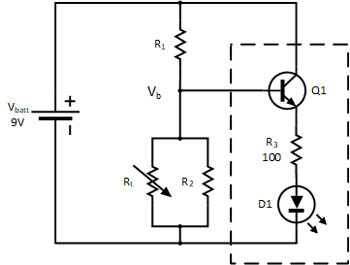

Figure 1 – Simple Thermo-detector Circuit

Note that the black box circuit in the schematics above is marked by the dashed rectangle. The followings are the specs for the black box:

1. *Vb = 3V* for the LED to turn on
2. *Vb ≤ 4.5V* for all values of *Rt*

## Procedure

First, let’s look at the equivalent resistance for the parallel sub-circuit in in Figure 1. This equivalent circuit is shown below:

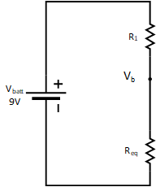

Figure 2 – Equivalent Resistor Network

The circuit in Figure 2 is now a simple series resistor network or a voltage divider circuit. Recall that for a series resistor network, the voltage across each resistor is proportional to the ratio of the value of that resistor to the total resistance. In the case of Figure 2:

$$V_{b}=V_{batt}\frac{R_{eq}}{R_{1}+R_{eq}}$$

*Eq. 1*

From our design requirement (b), we know that *Vb ≤ 4.5V.* Therefore, the ratio

$$\frac{R_{eq}}{R_{1}+R_{eq}}≤\frac{1}{2}$$

This can be achieved by setting $R_{eq}=R_{1}$.

Now, examining $R_{eq}$ by itself, we note that in a parallel resistor network,

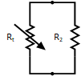

Figure 3 – Parallel Resistor Sub-Circuit

the equivalent resistance of the network can never be larger than the smallest resistor in the network. Therefore, by setting $R_{2}=R_{1}$, we ensure that no matter how large the value of $R_{t}$ is, the value of $R_{eq}$ is never larger than $R_{1}$, and consequently, $\frac{R_{eq}}{R_{1}+R_{eq}}$ for the series circuit in Figure 2 will never be larger than $\frac{1}{2}$.

Therefore, the circuit of Figure 1 will now be as shown below.

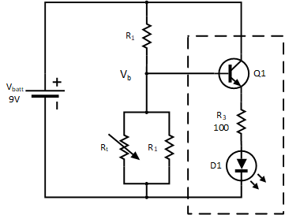

Figure 4 – Simple Thermo-detector Circuit with R2 = R1

Now, in order to determine the value of R1, we will use our design requirement (a) and the following steps.

1. Design requirement (a) states that *Vb = 3V* for LED to turn on. Referring to Figure 2 and Eq. 1: $$4=V_{batt}\frac{R_{eq}}{R_{1}+R_{eq}}$$ 
     
   However, $V_{batt}=9$. $$3=9\frac{R_{eq}}{R_{1}+R_{eq}}$$
2. Solving above equation for $R_{eq}$, we have $$R_{eq}=\frac{3}{6}R_{1}=\frac{1}{2}R_{1}$$
3. $R_{eq}$ for the parallel resistor sub-circuit, on the other hand, is given by $$R_{eq}=\frac{R_{1}R_{t}}{R_{1}+R_{t}} \\ Setting this equation equal to the one in step B: \\ \frac{R_{1}R_{t}}{R_{1}+R_{t}}=\frac{1}{2}R_{1} \\ and solving for R_{1}$$ 
     
   , we have $$R_{1}=R_{t}$$
4. Now, by looking at our data collected for $R_{t}$ for ambient and “cold” temperatures, we can pick a value to plug in for $R_{t}$ to get a value for $R_{1}$. Write your selected value for $R_{t}$ and $R_{1}$ below. $$R_{t}=______________ \\ R_{1}=______________$$

## Simulation

In real practice, once a design is completed on paper, engineers try to simulate the circuit to detect and correct any possible mistakes in the design.

1. Capture the schematic for your design in LTSpice. Your final schematic should look like the one below. Make sure to include and select the correct library for the LED D1.  
     
   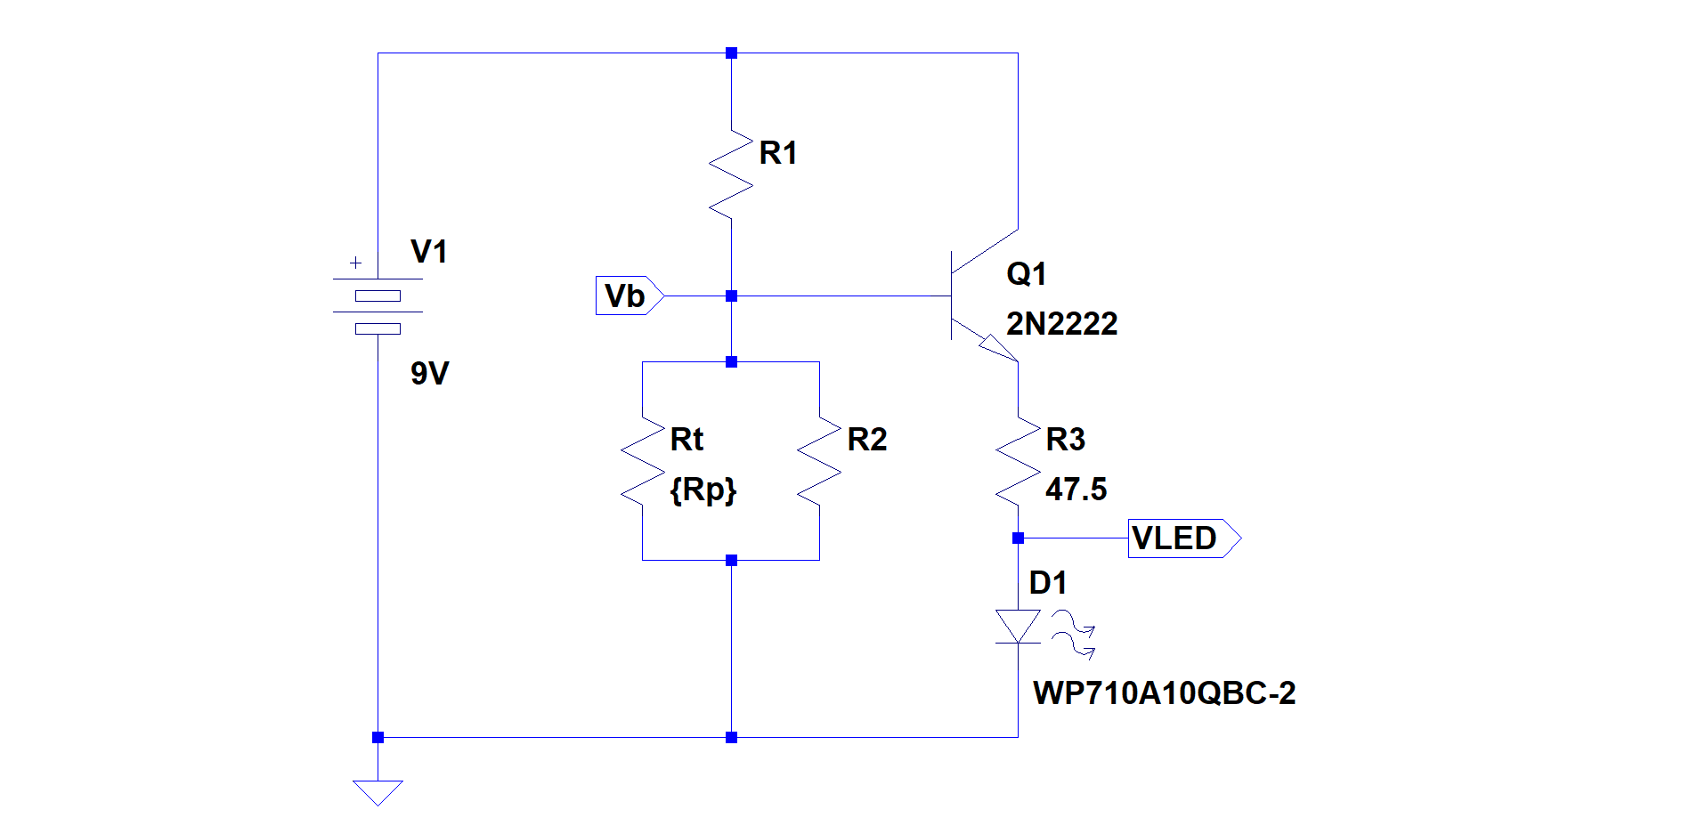

Figure 5 - LTSpice Simulation Circuit

1. Simulate your design for values of $R_{t}$ ranging from 80K to 800K to make sure the circuit is behaving as you expect it. From the simulation results, collect the values for $V_{b}$ in the table below for the different values of $R_{t}$ indicated.

|  |  |
| --- | --- |
| **Rt** | **Vb** |
| 100K |  |
| 140K |  |
| 200K |  |
| 220K |  |
| 240K |  |
| 800K |  |

## Build

Build your circuit from Figure 5 on a breadboard. Measure the voltage at Vb with respect to ground for when the LED is off and when the LED is on. Record the values below.

Vb for LED Off = _________

Vb for LED On = _________

1. A “black box” is usually referred to a circuit where we don’t know (or need to know) the details of the circuit as long as we know the required voltages and currents for input and output ports.